Serial No:
Final Exam
Part 2
Total Time (Part 2): 1hr
Total Marks (Part 2): 40
________________
Signature of Invigilator

CS-227: Digital Logic Design

Monday 27th May, 2019
Course Instructors
Dr Mehwish Hassan, Dr Adnan Saeed, Sana Hassan & Mehreen Alam.

_____________________________________________ _____________________
Student Name Roll No Section Signature

DO NOT OPEN THE QUESTION BOOK OR START UNTIL INSTRUCTED.
Instructions:
- This is Part 2, the design part of the exam.
- Attempt all of them. Read the question carefully, understand the question, and then attempt it.
- No additional sheet will be provided for rough work. Use the back of the last page for rough work.
- After asked to commence the exam, please verify that you have fourteen (14) different printed pages including this title page. There are total of 10 questions.
- Use permanent ink pens only. Any part done using soft pencil will not be marked and cannot be claimed for rechecking.
- Calculator sharing is strictly prohibited.

 | 1 | 2 | 3 | 4 | Total
Total Marks | 10 | 10 | 10 | 10 | 40
Marks Obtained

Refer to the following 4 k-maps for questions 1, 2 and 3:
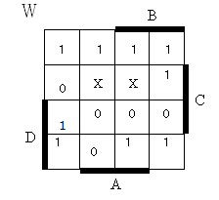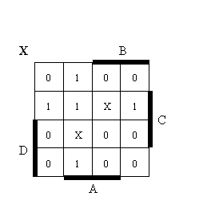
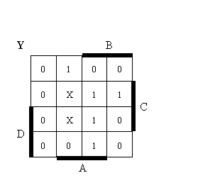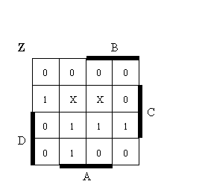

Question-1 [10 pts ]
Implement the four functions above using the read-only memory (ROM). Place Xs where connections need to be made.

Question-2 [10 pts ]
Implement the four functions above using the programmable array logic (PAL). Place Xs where connections need to be made. Note that all outputs must be a sum of no more than three product terms.

Question-3 [10 pts ]
Implement the four functions above using the programmable logic array (PLA). Place Xs where connections need to be made.

Question-4 [10 pts ]
Design a synchronous counter with T-flip flops that goes though the following binary repeated sequence: 0, 2, 3,4,5,6. Any un-used state is re-directed to the state having one less value than its own.

Question-5 [10 pts ]

Specify the size and implement a circuit using a PROM (programmable read only memory) that multiplies two 2-bit numbers (A₀A₁ and B₀B₁). Tabulate truth table and draw and label the logic diagram of this PROM.

